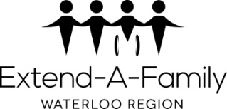Extend-A-Family Waterloo Region

# TERRITORIAL ACKNOWLEDGEMENT

We would like to begin by acknowledging the Indigenous Peoples and history of the land that we are on today.

Much of the work of Extend-A-Family Waterloo Region takes place on the traditional territory of the Anishinaabeg (Ah-nish-in-ah-beg), Chonnonton (Chun-ongk-ton), and Haudenosaunee (Hoe-den-no-show-nee) people. Our main office is situated on the Haldimand Tract, unceded land that was promised to the Six Nations in 1784 and includes 9.5kms on either side of Willow River (Grand River), from its source in Dundalk Township to its mouth at Lake Erie.

Although only approximately 47,000 (forty-seven thousand) of the 950,000 (nine hundred and fifty thousand) designated acres remain under the direct stewardship of the Six Nations today, we are grateful for the enduring presence, knowledge and philosophies of the Indigenous Peoples whose lands we respectfully share.

Extend-A-Family Waterloo Region actively works toward reconciliation through learning, community building, and sharing resources with local Indigenous organizations. We do this to affirm our commitment and responsibility to improve relationships amongst communities and our own understanding of local Indigenous Peoples and their cultures.

We invite you to take a moment to reflect on the lasting effect that residential schools and systems of oppression have had, and continue to have, on Indigenous communities and families, and to consider how we can each take immediate steps to contribute to moving forward in a spirit of decolonization, reconciliation, and collaboration.

Last review: September 2024